Soran Stomp Manager iOS App Store Download

For iOS: Scan to download on the App Store
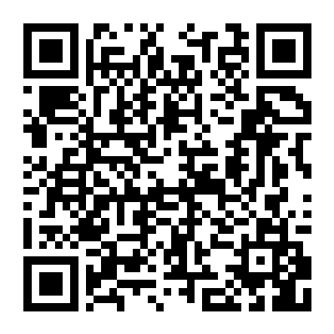
https://apps.apple.com/us/app/stomp-manager/id6754264644

