Soran Stomp Manager iOS App Store 下载

iOS用户：用App Store扫描二维码下载软件
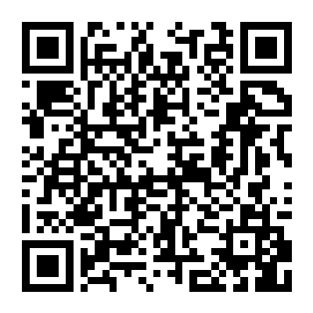
https://apps.apple.com/us/app/stomp-manager/id6754264644

